Maria Fernandez 6th A
Web 1.0, Web. 2.0, Web 3.0
Web 1.0: Web 1.0 refers to the first stage in the World Wide Web, which was entirely made up of web pages connected by hyperlinks.
Example: A Dictionary
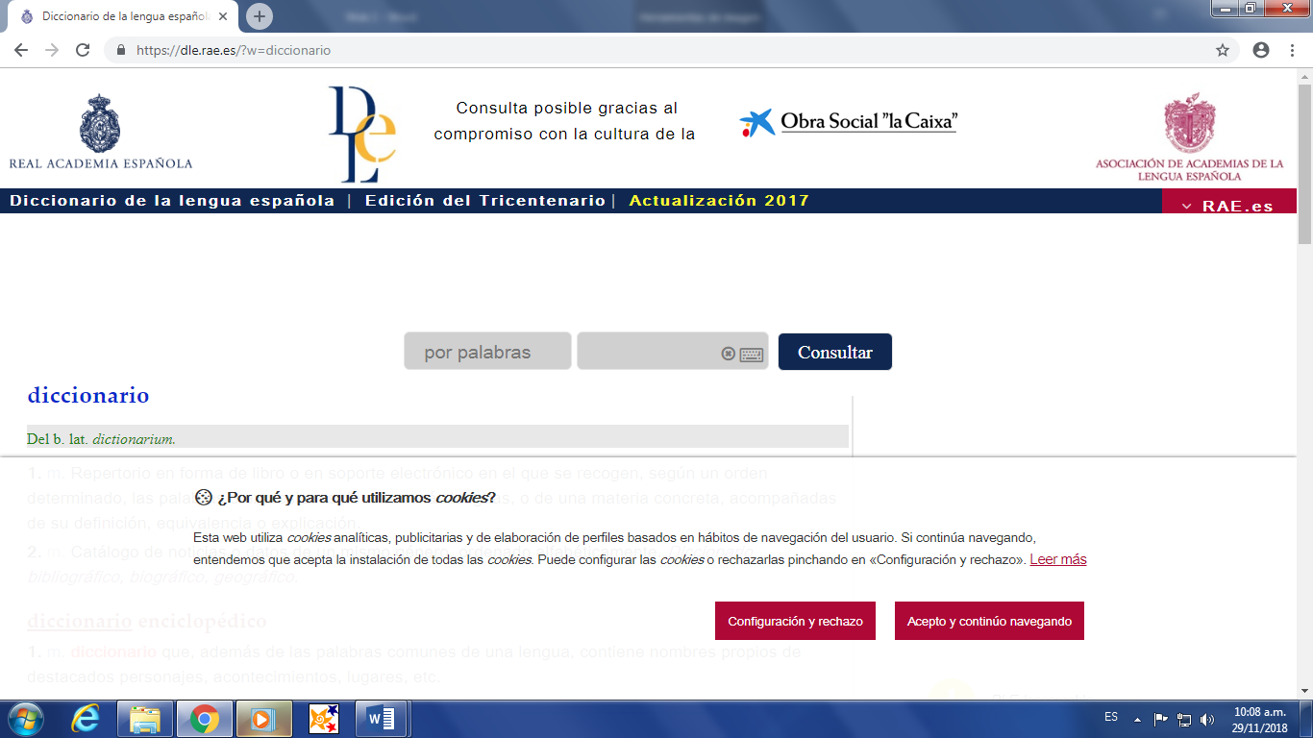
Web 2.0: Web 2.0 is the name used to the describe the second generation of the world wide web, where it moved static HTML pages to a more interactive and dynamic web experience. Web 2.0 is focused on the ability for people to collaborate and share information online via social media, blogging and Web-based communities.
Example: Instagram
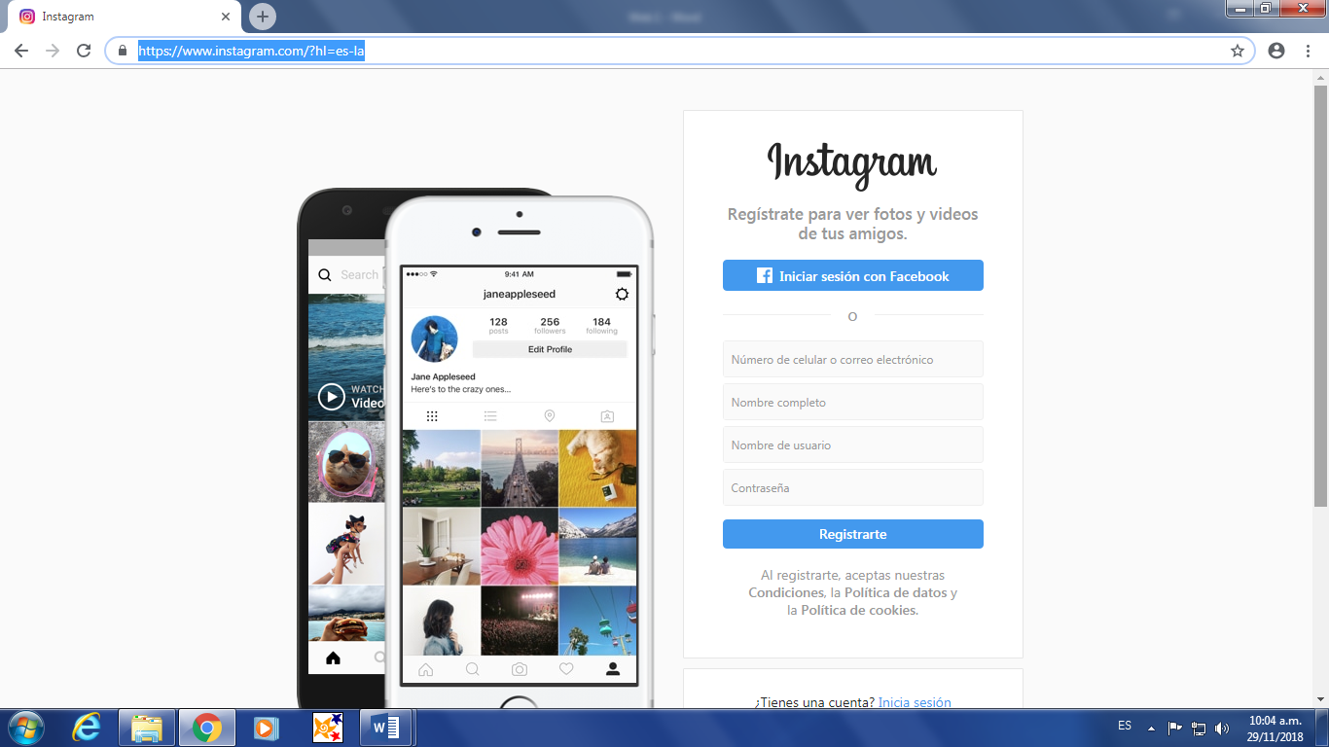
Web 3.0: Web 3.0 is slated to be the new paradigm in web interaction and will mark a fundamental change in how developers create websites, but more importantly, how people interact with those websites.
Example: YouTube
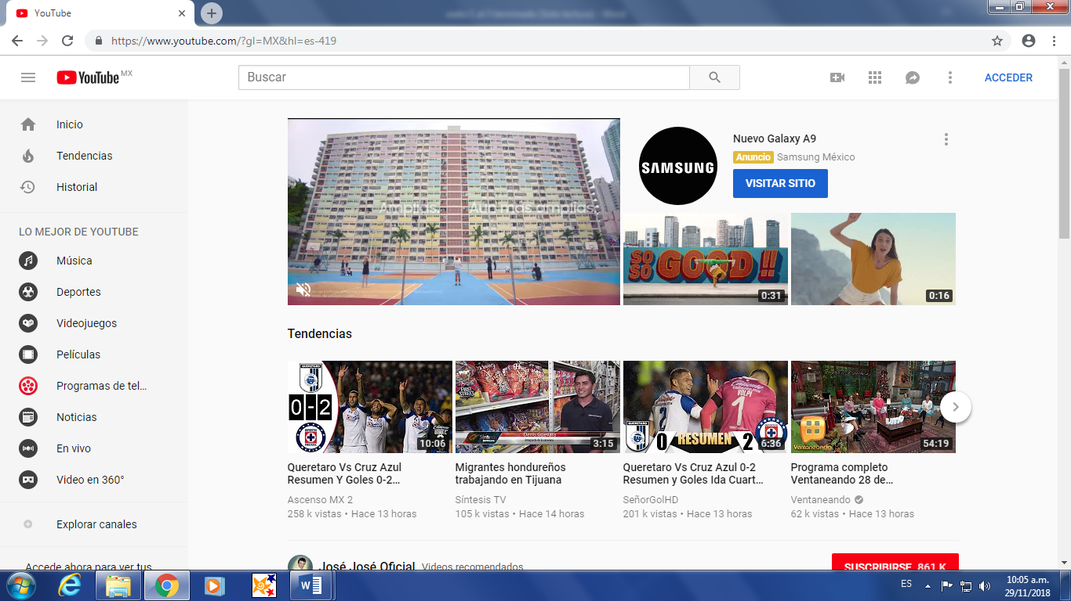

Web 4.0 is an open, linked and intelligent web it will also load web pages quicker with impeccable results.
Example: Siri
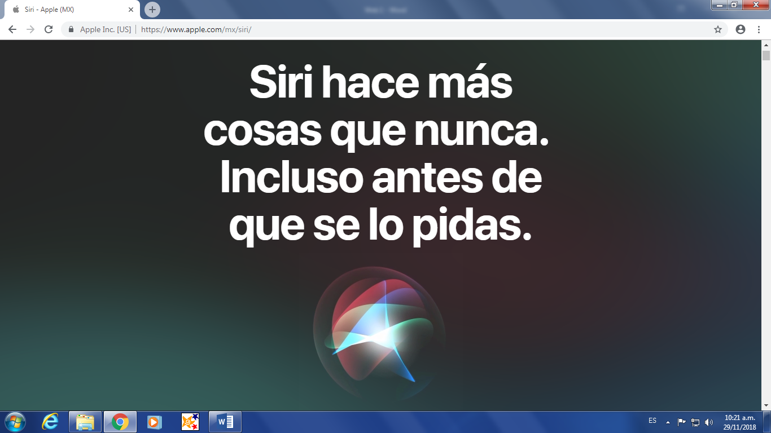

References:
“Basic Definitions: Web 1.0, Web. 2.0, Web 3.0”
https://www.practicalecommerce.com/Basic-Definitions-Web-1-0-Web-2-0-Web-3-0
(November 15, 2018)

“What does web 1.0 mean?”
https://www.techopedia.com/definition/27960/web-10
(November 26, 2018)

“What does web 2.0 mean?”
https://www.techopedia.com/definition/4922/web-20
(November 26, 2018)

“What does web 3.0 mean?”
https://www.techopedia.com/definition/4923/web-30
(November 26, 2018)

“What is web 4.0”
https://stephenletts.wordpress.com/web-4-0/
(November 29, 2018)

